**Name**: Ahmed wael Mohamed abdeltawab

**B.N**:152

**Topic**: Artificial intelligence

**Github link:**  <https://ahmed-wael629.github.io/ECE001/>

<https://github.com/Ahmed-wael629/ECE001>

# Artificial intelligence brief

Artificial intelligence is one of the most important scientific fields that scientists working on currently, it has a lot of uses in different field such as medicine and industry, it can be considered as the assistant to the human nowadays.

We see its effect on our life everyday such as internet and other electronic devices which don’t need human actions to work, industry have developed and extended and get much easier , there’s more expected achievements in this field in the future.

# Screenshots:

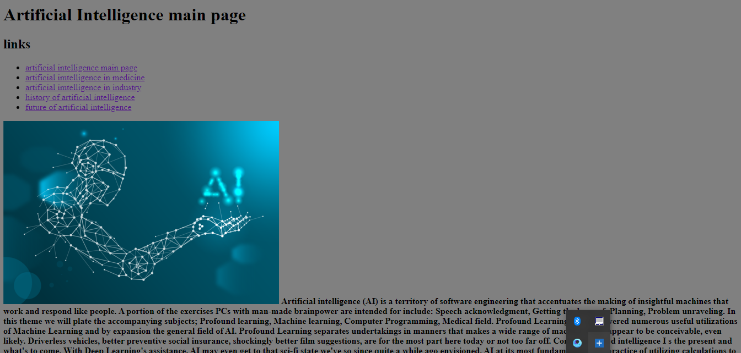

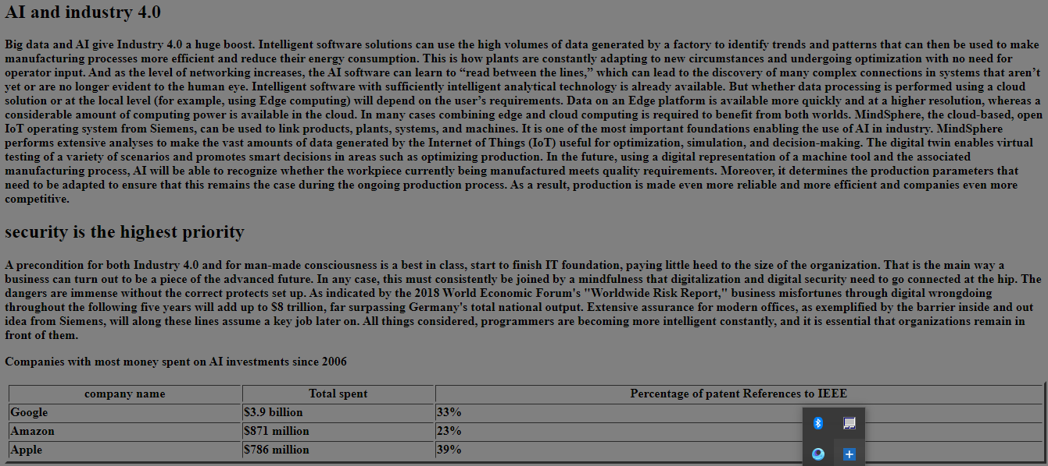

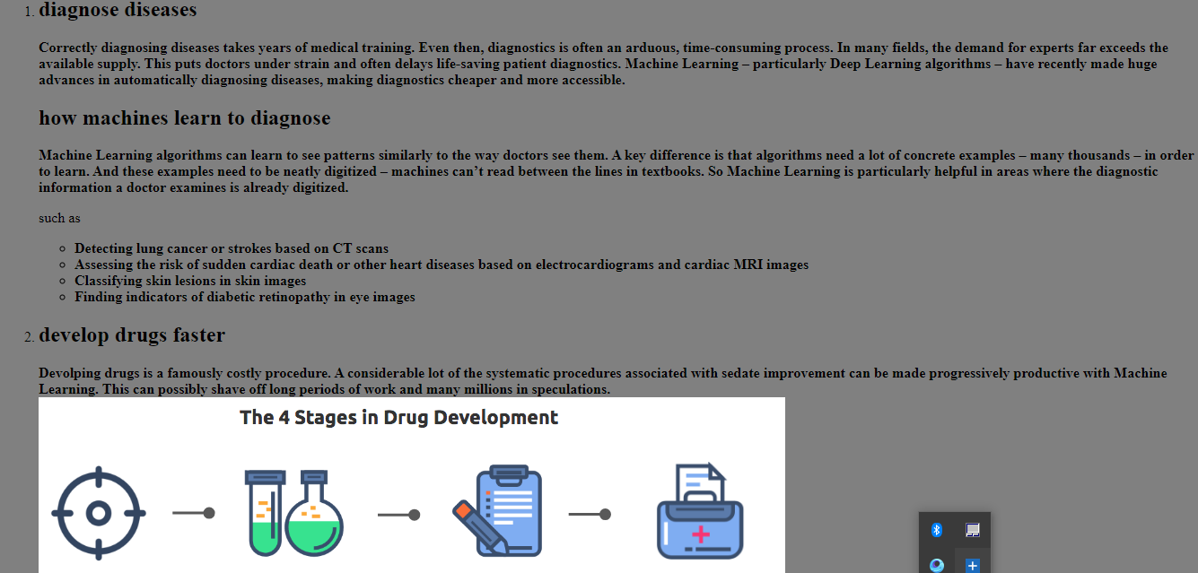

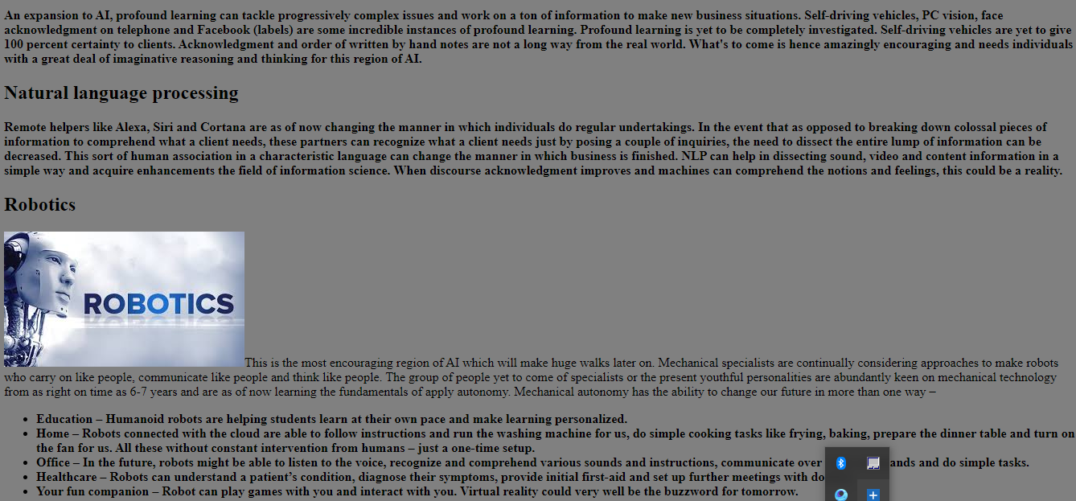

# Source Code:

